How to install Docker on Ubuntu using SNAP

Step 1:

Let’s check whether we have docker already installed or not as the first step.

When I typed the below command it says ‘cannot be found’ and requesting you to install either using SNAP or APT. In this doc, we will try installing using SNAP.

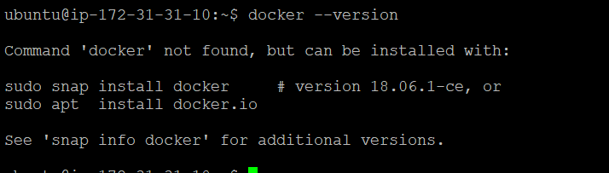

Step 2:

Execute the below command and it will be installed in couple of seconds.



Step 3:

Execute the below command to check whether it’s installed or not.



Yes it is installed.

Step 4:

Let’s check whether docker services are running or not ????

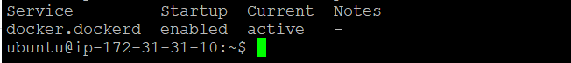

Step 5:

How to disable the docker services ??

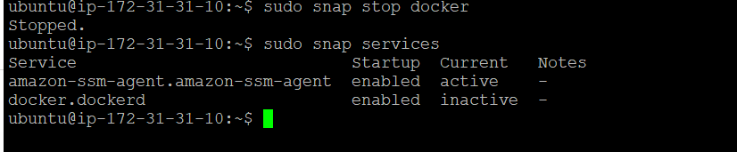

See we have stopped the docker service and used the other command to list out whether docker services are running or not. And it gives you under the current column that it is inactive.

Step 6:

Let’s try to start the docker services again.

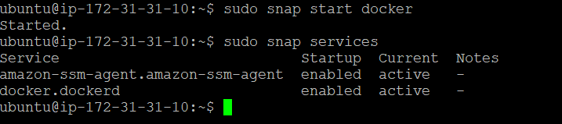

Step 7:

How to remove the docker using SNAP now ?



Step 8:

If you see now, the docker is not installed.

